## **Guided LAB - 303.9.2 - Basic Inheritance Example**

# Introduction

The process by which one class acquires the properties (data members) and functionalities (methods) of another class is called **inheritance**. The aim of inheritance is to provide the reusability of code so that a class has to write only the unique features, and the rest of the common properties and functionalities can be extended from the other class.

# Lab Overview:

In this lab, we will explore and demonstrate Java Inheritance.

# 

# Learning Objective:

By the end of this lab, Learners will be able to use Inheritance in Java.

# 

# Instruction:

**Child Class:**

The class that extends the features of another class is known as a child class, subclass, or derived class.

**Parent Class:**

The class whose properties and functionalities are used (inherited) by another class is known as the parent class, superclass, or base class.

# 

# Begin

In this lab, we have a base class, **“Doctor,”** and a subclass, **“Surgeon.”**

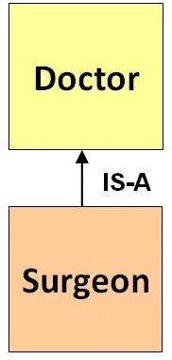

**Step 1:** Create a Java project named “**inheritanceDemo.**”

**Step 2:** Create a class named **Doctor,** and add the code below.

**Doctor**.java class

| public class Doctor {  String DoctorName;  String Department;  public void Doctor_Details() {  System.*out*.println("Doctor Details...");  }  } |
| --- |

**Step 3:** Create a class named **Surgeon,** and add the code below.

**Surgeon**.java class

| **public class Surgeon extends Doctor {**  **void Surgeon_Details() {**  **System.*out*.println("Surgeon Detail...");**  **System.*out*.println(Department = "Cardio");**  **}**  **}** |
| --- |

**Step 4:** Create a class named **Hospital.** In thisclass, we will create a **main()** method.

**Hospital.**javaclass

| **public class Hospital {**  **public static void main(String args[]) {**  **Surgeon s = new Surgeon();**  **s.Doctor_Details();**  **s.Surgeon_Details();**  **}**  **}** |
| --- |

The project hierarchy will look like this:

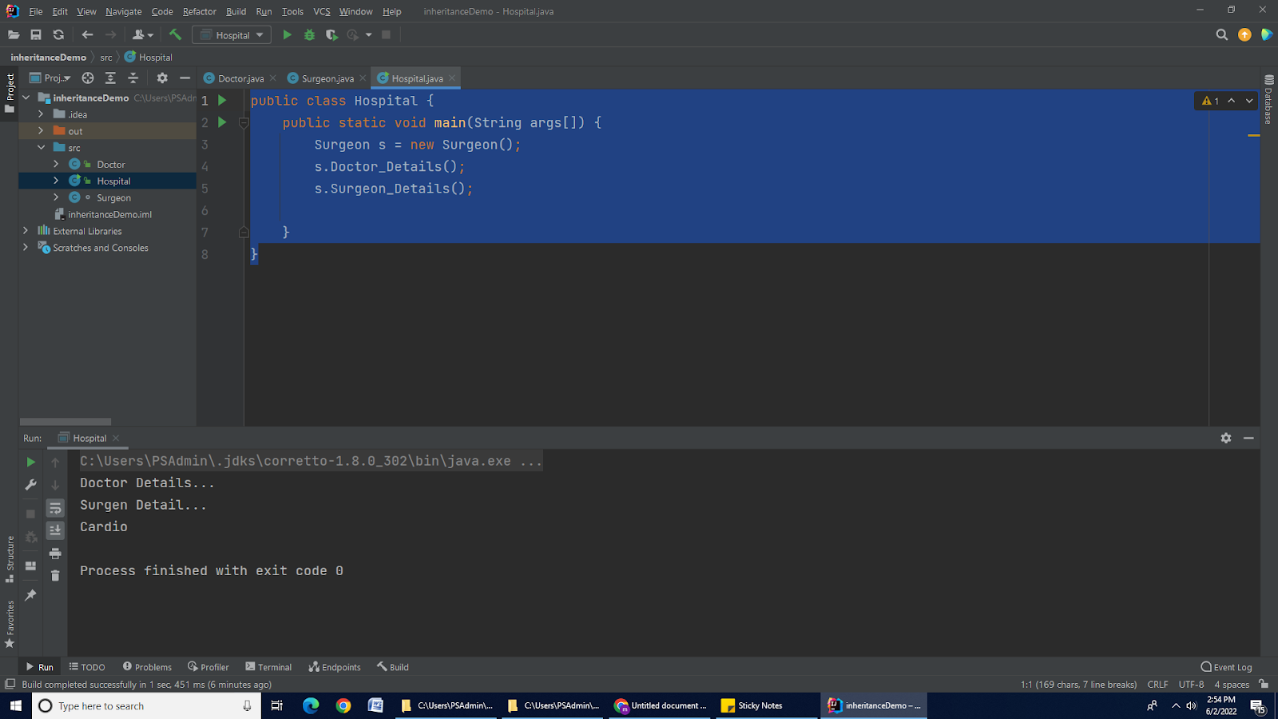

**Step 5:** Run your Java Project.

**Output on Console:**

| **Doctor Details...**  **Surgeon Detail...**  **Cardio** |
| --- |

Based on the above example, we can say that Surgeon IS-A Child. This means a child class has an IS-A relationship with the parent class. This inheritance is known as the IS-A relationship between the child and parent class.

**Submission Instructions:**

Include the following deliverables in your submission -

* + Submit your source code using the Start Assignment button in the top-right corner of the assignment page in Canvas.

**CANVAS STAFF USE ONLY: Canvas Submission Guideline:**

| **Instructions for Canvas Assignment Creation** |
| --- |
| **Assignment Name: GLAB - 303.9.2 Basic Inheritance Example**  **Points:** **100**  **Assignment Group: Module 303: Java SE Review (Not Graded)**  **Display Grade As: Complete/Incomplete**  **Do not count this assignment towards the final grade: Checked**  **Submission Types: File uploads**  **Everything else is the default.** |